**Manual for Thermoelectricity Measurements**

**(I) Assembling of of the Device (STM)**

**Substrate Holder**

1. A Peltier heater was put under the sample plate, which was electrically and thermally isolated by a ceramic plate.

2. The other side of the Peltier was attached to the Cu plate to release the heat.

**NOTE:** A thermal pad was placed on the top and bottom of the Peltier to allow better thermal contact with the contact surface.

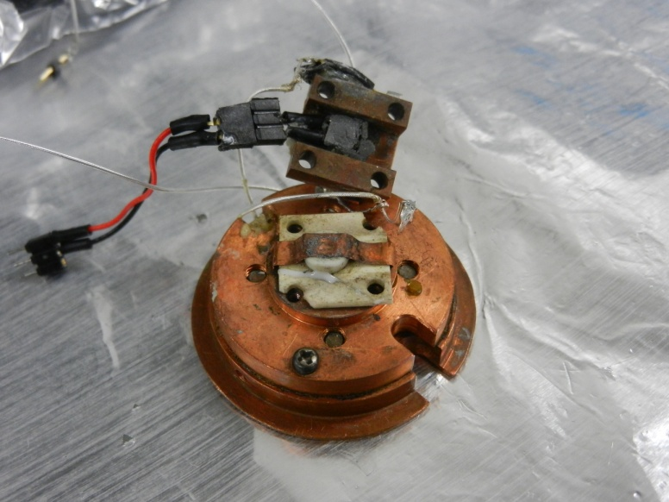

**Tip Scanner**

1. Structure of the tip scanner is shown as follows.

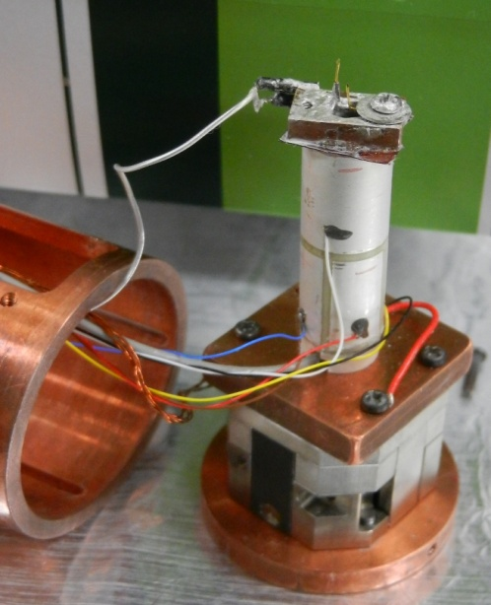

1. Insert the tip scanner into the STM box carefully as shown in the following figure.

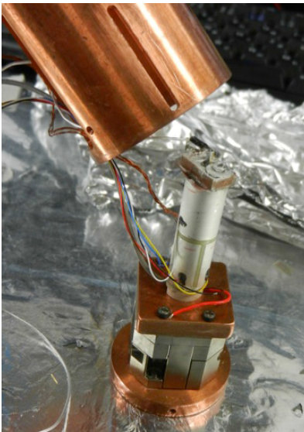

1. Next, attach the screws to connect the tip scanner and STM box as shown below.

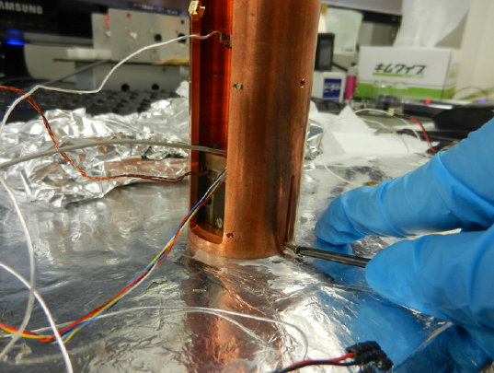

1. Adjust the position of the tip scanner below tightening the screws.
2. Use the screw at the side to hold the cable for the temperature sensor (measurement of the STM tip side) as shown below.

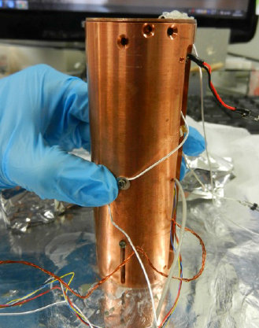

**(II) Description of the STM sample setup**

**Preparation of STM tip**

1. STM trip is prepared using mechanical cutting.

2. Next, the tip is fixed to its position by (i) inserting into the tip holder or (ii) using the screw to hold its position.

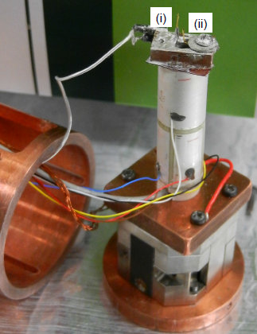

**Fixing the substrate to the Substrate Plate**

**1 .** Screw 2 & 4 should be attached at all times to hold the substrate plate and STM bottom plate together.

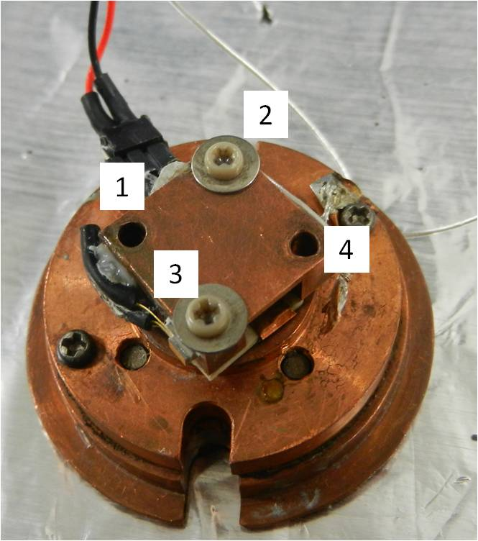

2. Clean the substrate plate using acetone.

3. Next, follow the steps in (A) or (B).

**(A) If taking the substrate was immersed in the solution:**

i) Placed the substrate on the substrate plate.

ii) Leave it for 1 minute so that the solvent will evaporate.

iii) Attach screw (with washer) for position 1 & 3 to hold the substrate.

**NOTE:** Remember to attach the bias voltage line together with screw 3.

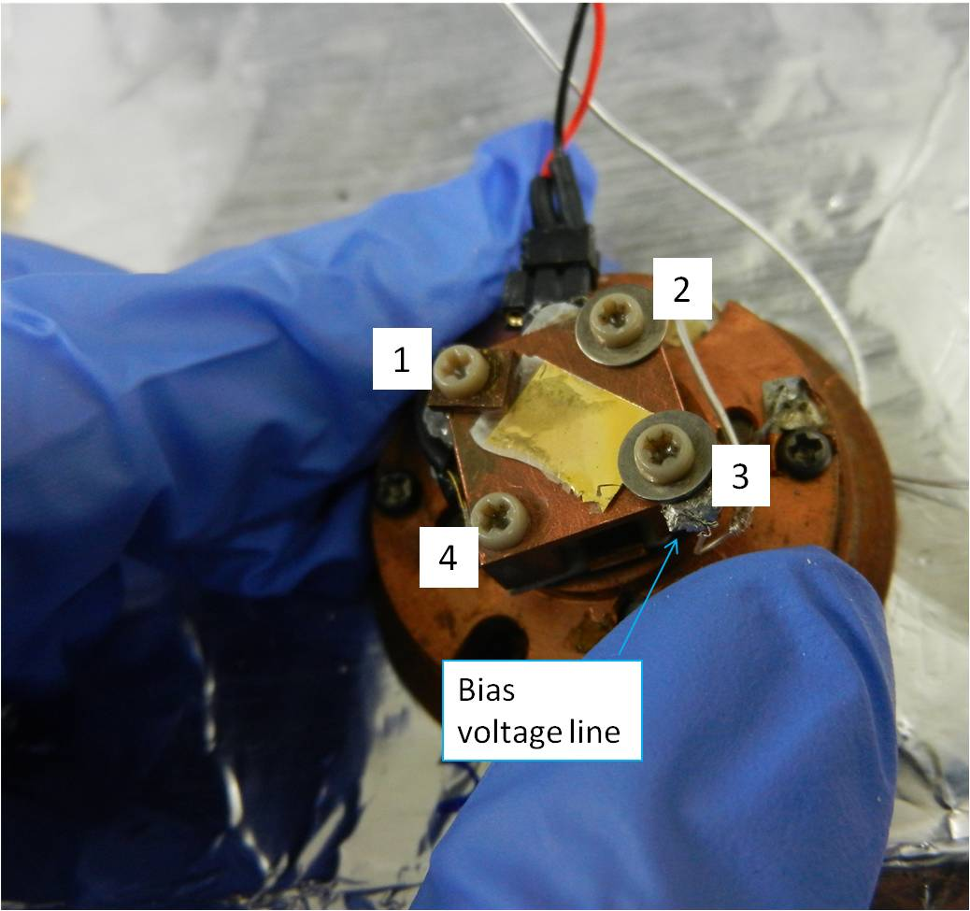

iv) Next, use the multimeter to confirm the connection between the bias voltage line and substrate.

v) Place the STM base plate to the STM body and screw both parts together.

**NOTE:** Be careful when holding the cable for bias voltage line as it is flimsy.

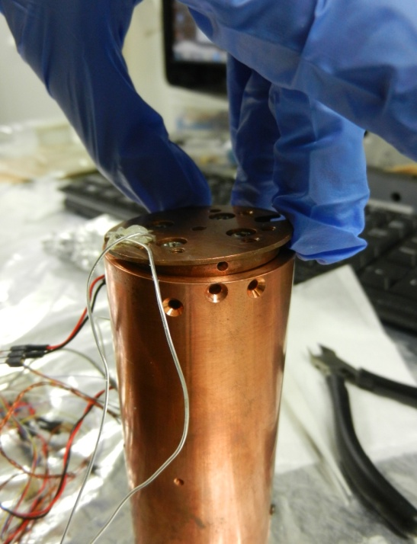 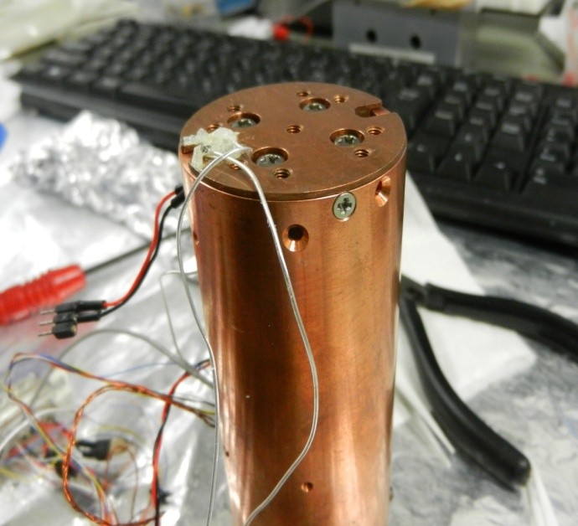

vi) Next, connect the cable for the temperature sensor to the one from the 25-pin connector (structure of the 25-pin connector shown below).

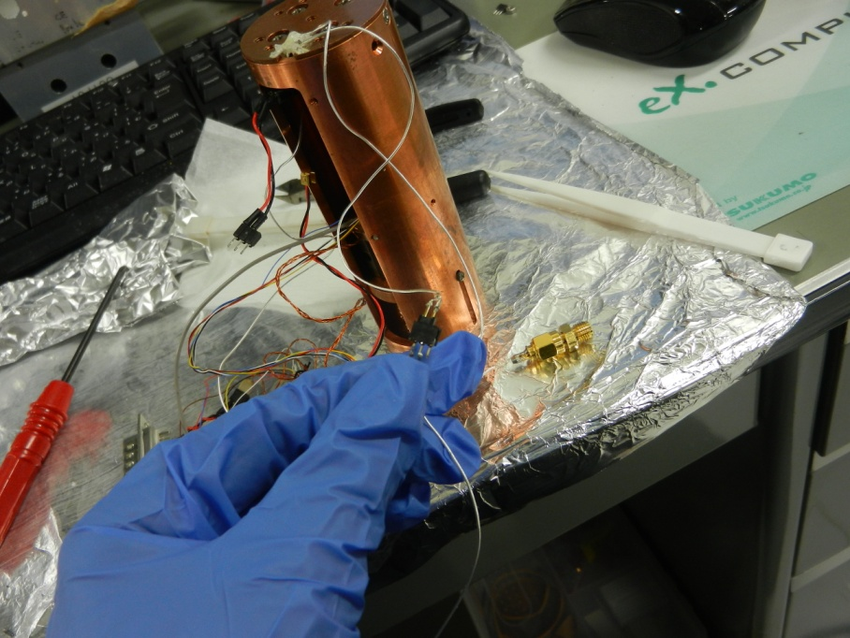

vii) Slowly, bring the STM box to the stainless steel box container.

viii) Connect the 25-pin connector (male) to the 25-pin connector (female) which had been attached to the container. The value for room temperature (~278K) should be shown on the temperature controller.

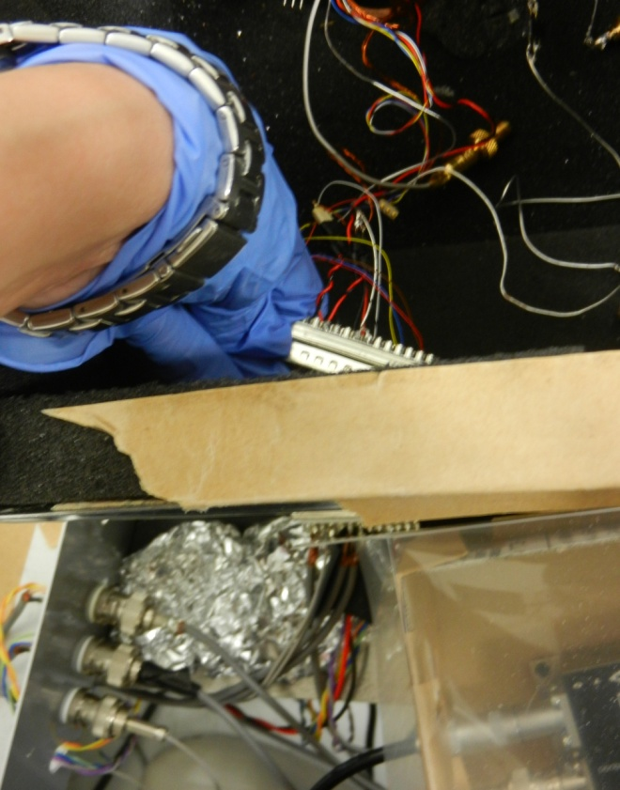 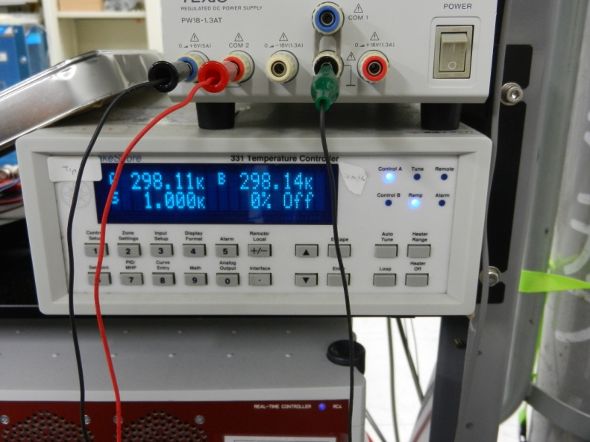

ix) Next, connect the tunneling current line to the connector marked **T** as shown below.

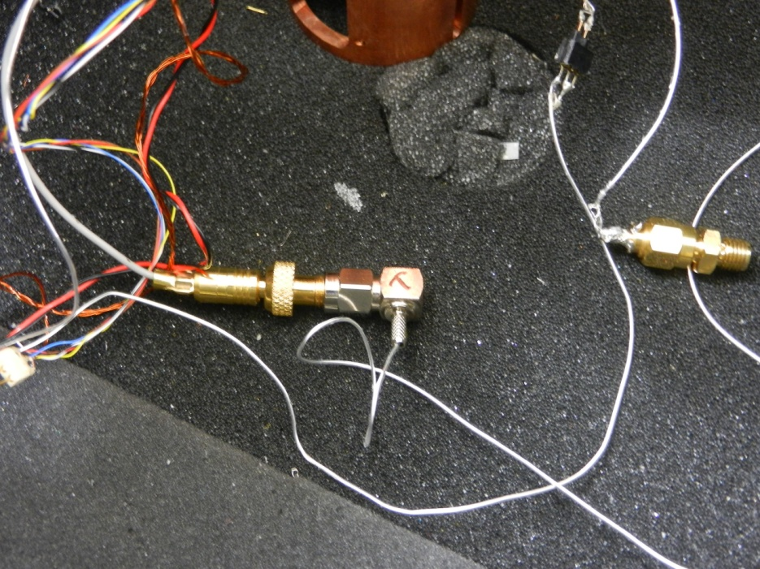

x) After that, connect the bias voltage line to the connector marked **VB** as shown below.

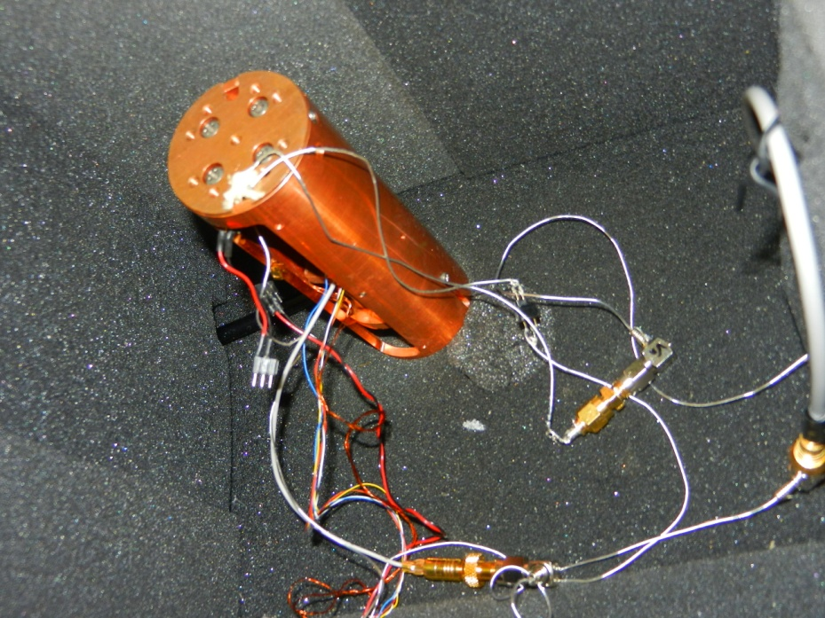

**(B) If applying drop cast method for preparation of the sample**

i) Attach screw (with washer) for the position 2 & 4 to hold the substrate

ii) Add a drop of solvent (containing the molecules) onto the substrate and allow the solvent to evaporate (~1-2 minutes) before attaching the screw (with washer) position 2 & 4 to hold the substrate.

iii) Repeat step (iv - x) in part **A**.

**Table:** Pin assignment for 25-multipin connector.

|  |  |
| --- | --- |
| Temperature sensor (tip) | 3 and 4 |
| Temperature sensor (sample plate) | 6 and 7 |
| Positioner | 14 and 15 |
| Heater | 18 and 19 |
| Piezo (x- motion) | 20 and 21 |
| Piezo (y- motion) | 22 and 23 |
| Piezo (z- motion) | 24 and 25 |

**III) Test the Connection**

i) After setting up the sample, we have to test whether the connection is ok. First, fix the setpoint current. The modules used in Nanonis should look as follows.

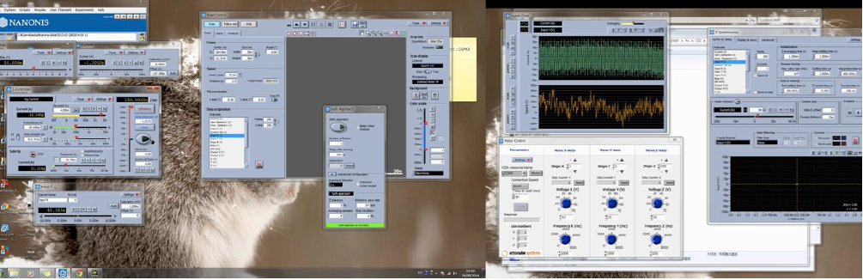

ii) Turn on the output supply for Z (picture below).

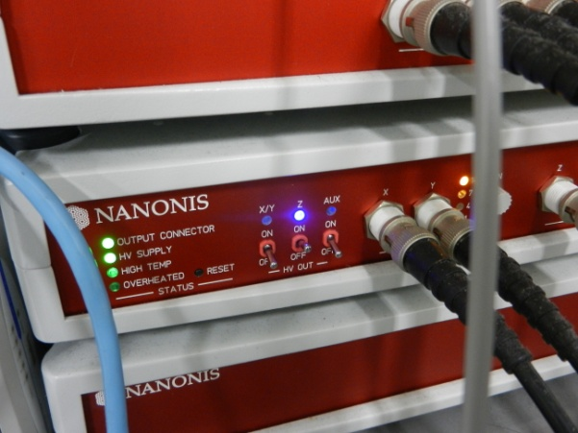

iii) First, use the “Motor Control” module to control the coarse approach. Usually, voltage for **Z** used is ~20V. **NEVER** use the value >30V as it would break the Attocube positioner.

iv) When, it feels like that the tip is close to the surface of the substrate (sharp spikes shown in the “Signal Chart” module, activate the “ Auto Approach” module.

**Note:** If needed, use smaller voltage for **Z, ~**16V**.**

v) When the setpoint value is reached, the “Auto Approach” will automatically turn OFF.

Adjust the “Proportional” and “Time Constant” if the tip is not stable. If a stable tip at the selected setpoint still cannot be obtained, then change the STM tip by opening the device and repeat the steps in **II** again. But it the stability is **OK**, then proceed to the next step.

vi) Once a stable tip is obtained, withdraw the tip by using the “Motor Control” module.

Usually, voltage Z ~20V is used. Withdraw around 600steps.

vii) Next, connect the cable for the Piezo heater as shown below. Turn on the Power supply for the heater.

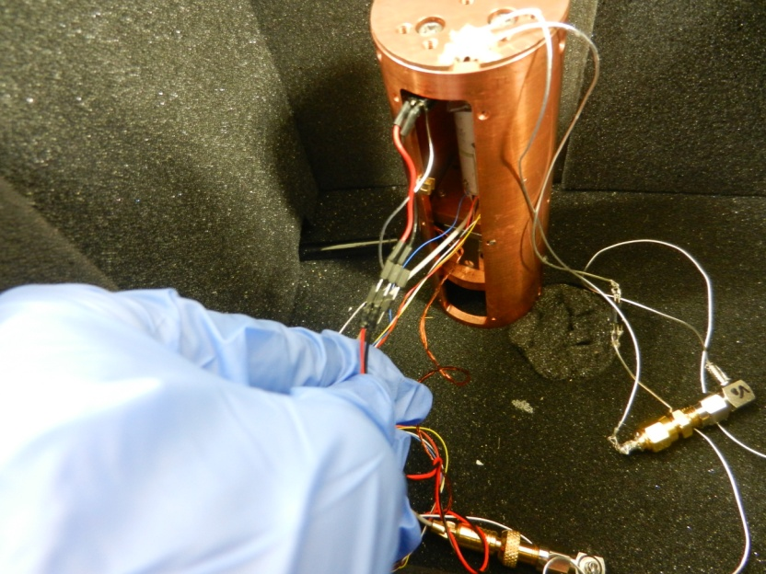

viii) Close the container with its cover.

ix) Flow Ar air into the container for about 5 minutes.

**Voltage Measurement**

i) Adjust the voltage on the Power Supply for the Peltier to create the ΔT needed.

ii) When the stable ΔT is achieved, activate the “Auto Approach” module.

iii) Adjust the stability of the tip using the steps mentioned previously if needed.

iv) Next, perform current-distance measurement at least 1-3 times to check if there is

presence of a molecular junction. A plateau will be observed if there are junctions. Save the

data in Z spectroscopy.

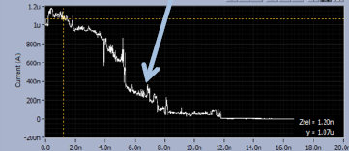

v) Also, try to disable the feedback to check the how long the junction can be stable.

vi) Make sure the Labview program “switch 6V-ck z spectroscopy jimmy” is open and “history-two channels ck(amend)” module to record the switching process of the current and voltage. The parameter should look as follows:

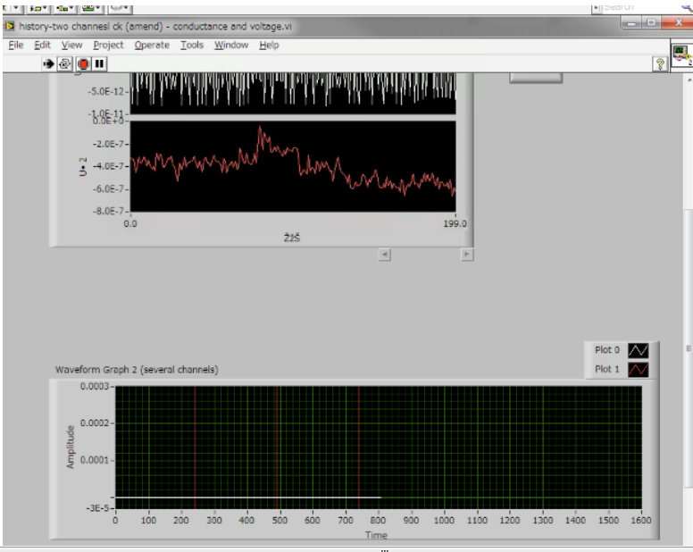

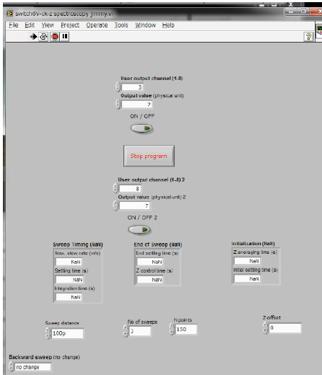

**NOTE:** When output channel 3 is activated, it means that the connection is to the current

amplifier. In other words, when output channel 8 is activated, the connection is to the voltage

amplifier.

vii) Remember to set the measurement channel for Input 4 in the “Z spectroscopy” module.

Also, remember to select “Save all” to save all measurements.

viii) Now, activate channel 8 to perform the voltage measurements.

ix) After each set of measurements taken, activate channel 3 (to connect to current amplifier again) to check the stability of the junction. If the junction is still stable, repeat step (viii) again. If not, activate the feedback again and check if a stable junction can be obtained. The deactivate the feedback and see if the junction can be stable for ~1sec. If it is possible, then

repeat step (viii) again.

x) Step (viii) and (ix) will be repeated for a few times. Remember to save the data in Z

spectroscopy for the measurements. Remember to stop the “history-two channels ck(amend)”

module and save the data.

**IV) Analysis of the Data**

i) Create the folders for the range of voltage measurement data (eg: folder 1, folder 2, etc…)

ii) Open the Labview program “Nanonis file splitter”. Add the raw data from Z spectroscopy

measurement (eg: Z-Spectroscopy003) into “Nanonis data file while the folder (eg: z3) and

run the program. The program will automatically split the measured data into the folder.

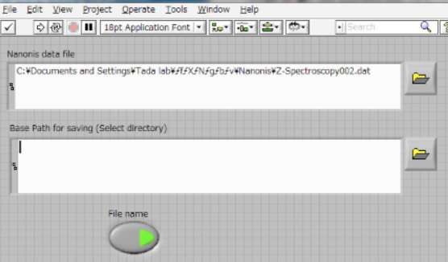

iii) If there were a few sets of data measured during the same ΔT, repeat step (i) and (ii) for

all of them. After that, combine the data into a MAJOR folder (eg: z3-z8) in the case where

there are 8 folders.

iv) Add the MAJOR folder into “Path” for the labview program “OFFSET ADJUST ReadIS

Voltage (CK3) mod by Oyabu3” and run the program. Run the program and click OK.

Unwanted data can also removed by clicking “select”. This process is similar to that for

“Break Junction” analysis.

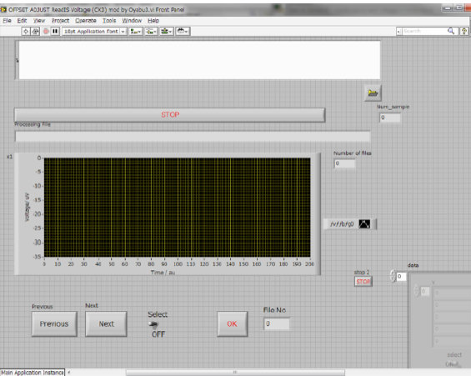

v) Use labview program “read_stored_files voltage(a)” to read the file analyzed using

““OFFSET ADJUST ReadIS Voltage (CK3) mod by Oyabu3”.